**Contents**

Code 2

Code and docs added to github 2

Running the python program 3

MySQL Workbench – Final transposed records with json contents 3

Json file under nested folder structure 4

# Code

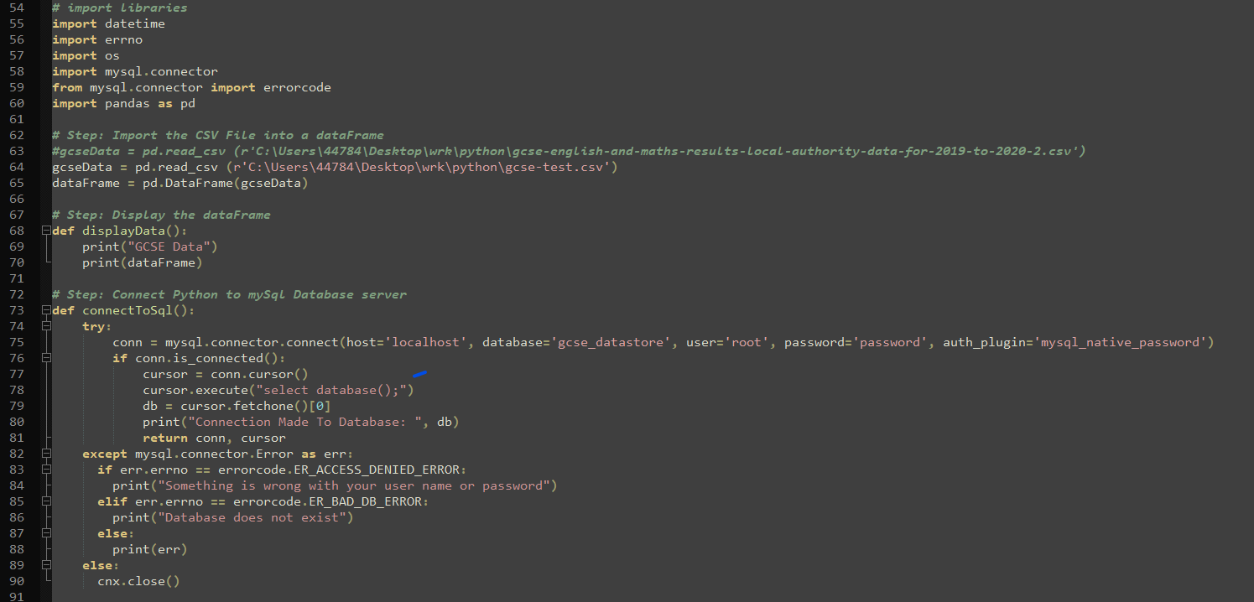

# 

# Code and docs added to github

[learn-mine/python-mysql-json-poc (github.com)](https://github.com/learn-mine/python-mysql-json-poc)

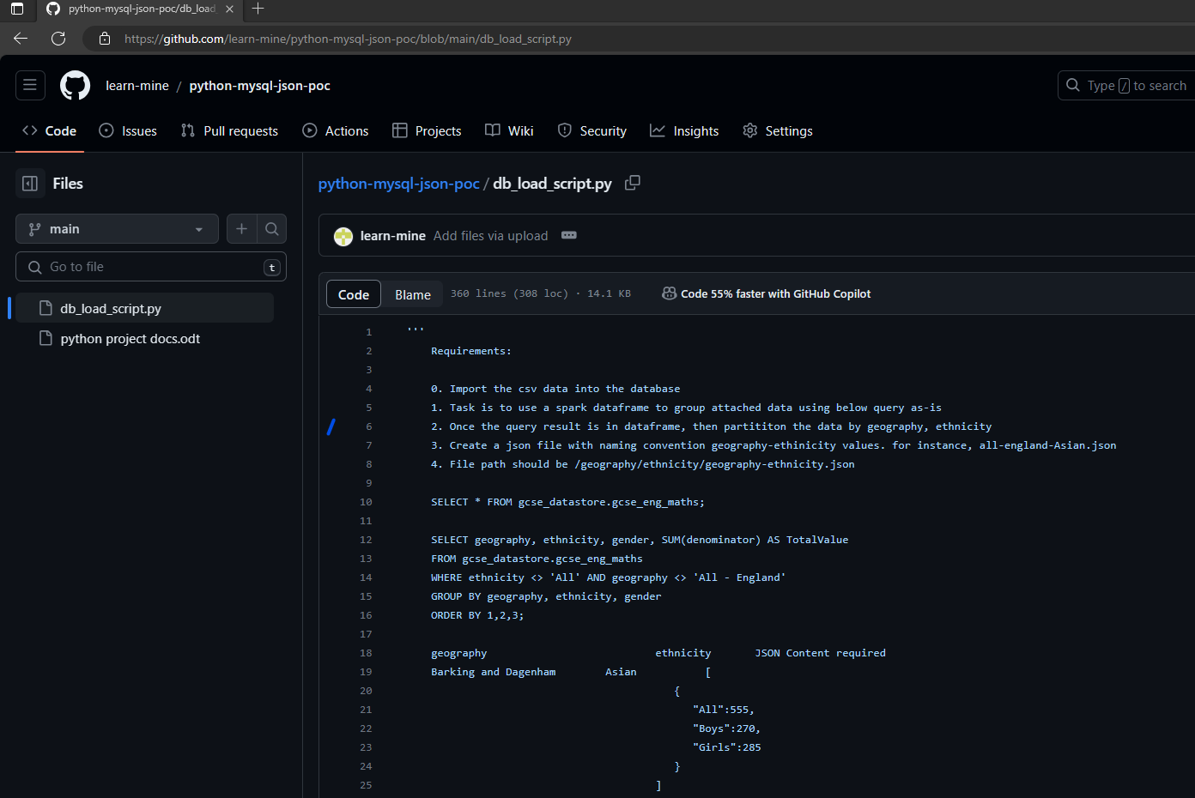

# Running the python program

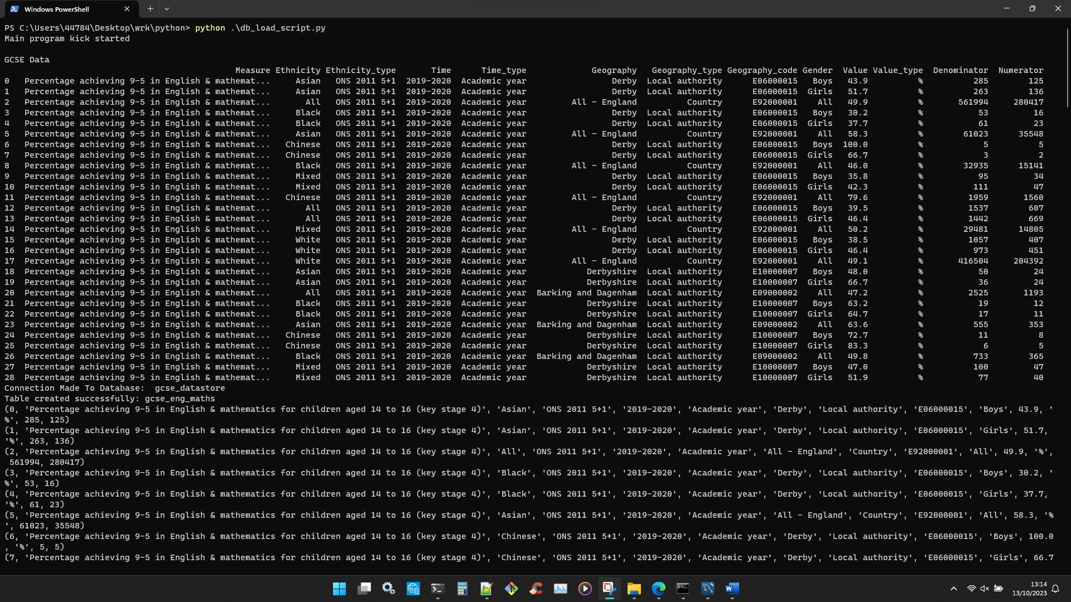

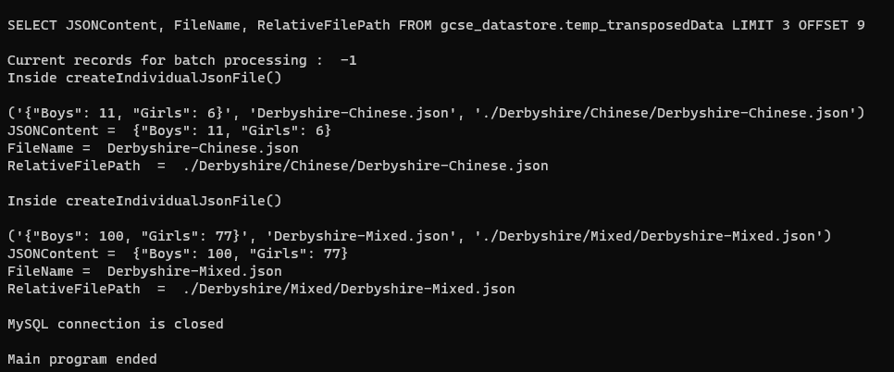

# MySQL Workbench – Final transposed records with json contents

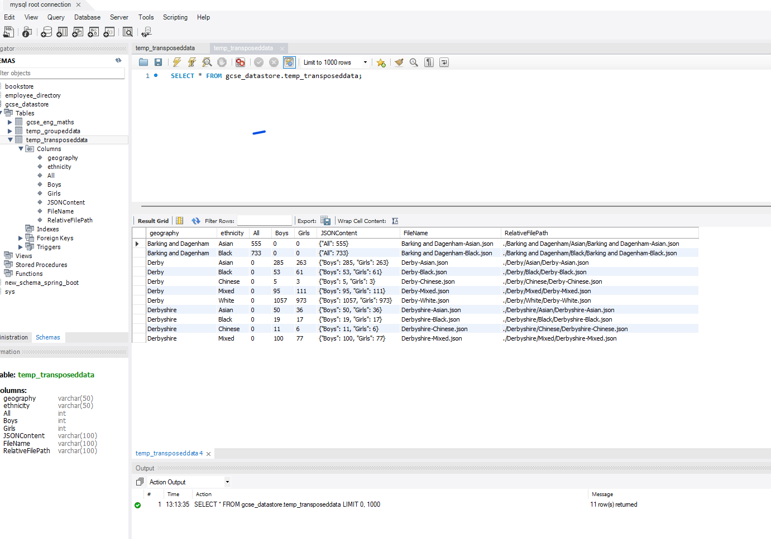

# 

# Json file under nested folder structure

